**ITA0448 – STATISTICS WITH R PROGRAMMING FOR VECTORIZED EXPRESSIONS**

**SUBMITTED BY: DEVADARSHINI J REG NO: 192124092**

**DATE: 20/03/2023**

1. **Consider two vectors, x, y x=c(4,6,5,7,10,9,4,15) y=c(0,10,1,8,2,3,4,1) What is the value of: x*y.**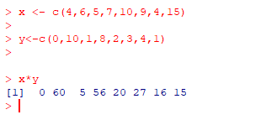
2. **Consider two vectors, a, b a=c (1,2,4,5,6) b=c(3,2,4,1,9) What is the value of: cbind(a,b).**

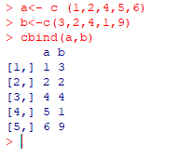

1. **Vector v is c(1,2,3,4) and list x is list(5:8), what is the output of v*x[1]?**

**SOL: Error in v * x[1] : non-numeric argument to binary operator**

1. **Vector v is c(1,2,3,4) and list x is list(5:8), what is the output of v*x[[1]]?**

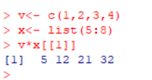

1. **X is the vector c(5,9.2,3,8.51,NA), What is the output of mean(x)?**

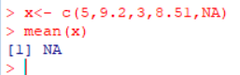

1. **Give a function in R that replaces all missing values of a vector x with the sum of elements of that vector?**

